Anti-Bullying Policy 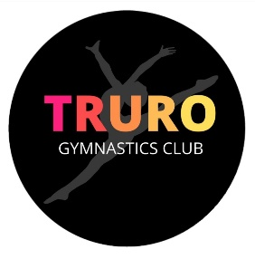

Bullying includes a range of abusive behaviour that is repeated and intended to hurt someone either physically or emotionally. Bullying of any kind involving the gymnast, staff and parent of Truro Gymnastics Club within lesson or outside them will NOT be tolerated.
Gymnasts of the club have responsibilities to look after one another and uphold friendly and supportive behaviours to those around them. We expect gymnasts to practise skills such as listening to one another and showing great respect to everyone at the club. Gymnasts are expected to respect the fact that everyone is different and have different needs when it comes to learning and developing their skills.
Everyone is expected to help create a positive learning environment so that everyone can come to classes and training sessions with a good outlook. s are expected to ensure that everyone is included, and no one is left without a friend.
If problems should arise, it’s important they are brought to the attention of the main coach so that any issues can be handled in a positive way. If you see something or experience something that makes you upset, you must tell a responsible adult, whether that’s a parent, coach or assistant coach.

