Code of Conduct 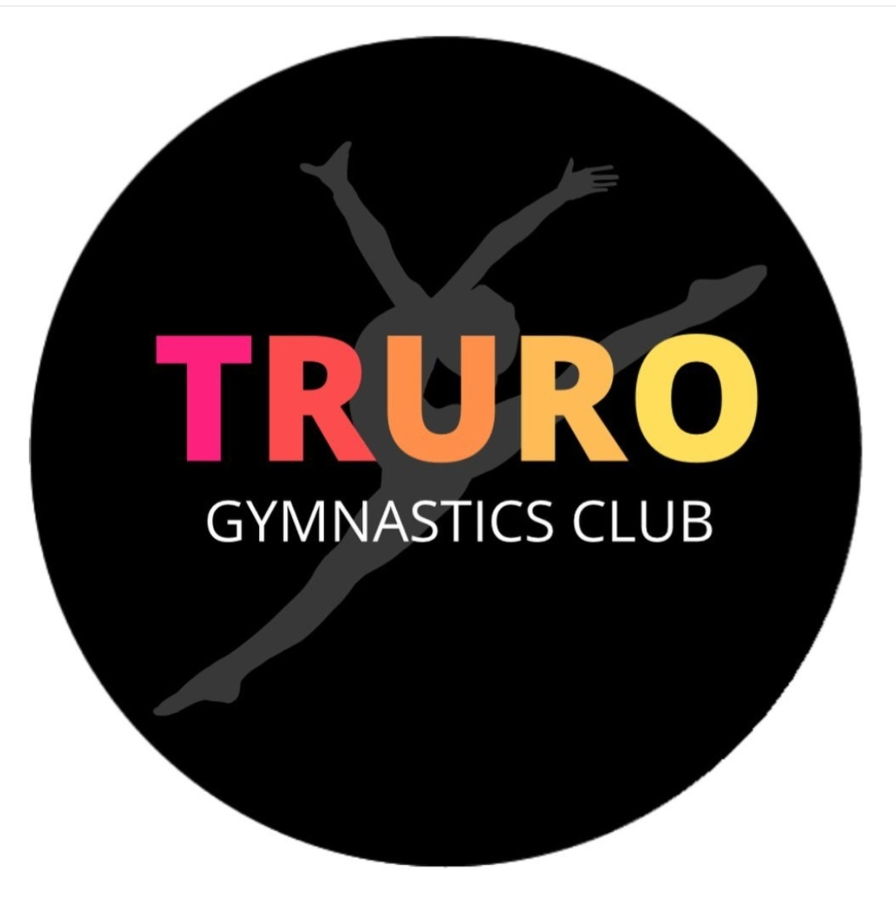

Truro Gymnastics Club Standards of Conduct for Gymnasts and Participants

We are fully committed to safeguarding and promoting the well-being of all our members.
The club believes it is important that members, coaches, administrators and parents associated with the club should, at all times, show respect and understanding for the safety and welfare of others.

All Gymnasts and Participants must:-

- Gymnasts are expected to be prompt to sessions and be ready for an immediate start.
- Gymnasts will be kind and respectful to all other teammates, parents, coaches and staff. No disrespect will be tolerated. Bullying of any kind will NOT be tolerated
- All gymnasts must participate within the rules and respect coaches, judges and their decisions
- Gymnasts are expected to listen carefully to ALL coaches and assistants in order to keep them safe.
- Gymnasts should keep to agreed timings for training and competitions or inform their coach, or if they are going to be late
- Gymnasts must wear suitable attire for training and events as agreed with the coach. Keep all long hair tied back. Remove all body jewellery
- Gymnasts must not smoke, consume alcohol or take drugs of any kind whilst representing the club at competitions or other events
- Gymnasts should treat all equipment with respect
- Gymnasts should NEVER attempt new tricks without the permission or knowledge of one of the coaches
- Gymnasts must inform the head coach of any injuries or illness they may have before the warm-up begins
- Gymnasts should not eat or chew gum during a session
- Gymnasts must not use bad language
- Gymnasts should remain with coaches at the end of a session until collected by their parent or guardian
- Gymnasts are expected to help cultivate a positive environment within sessions.

