Code of Conduct 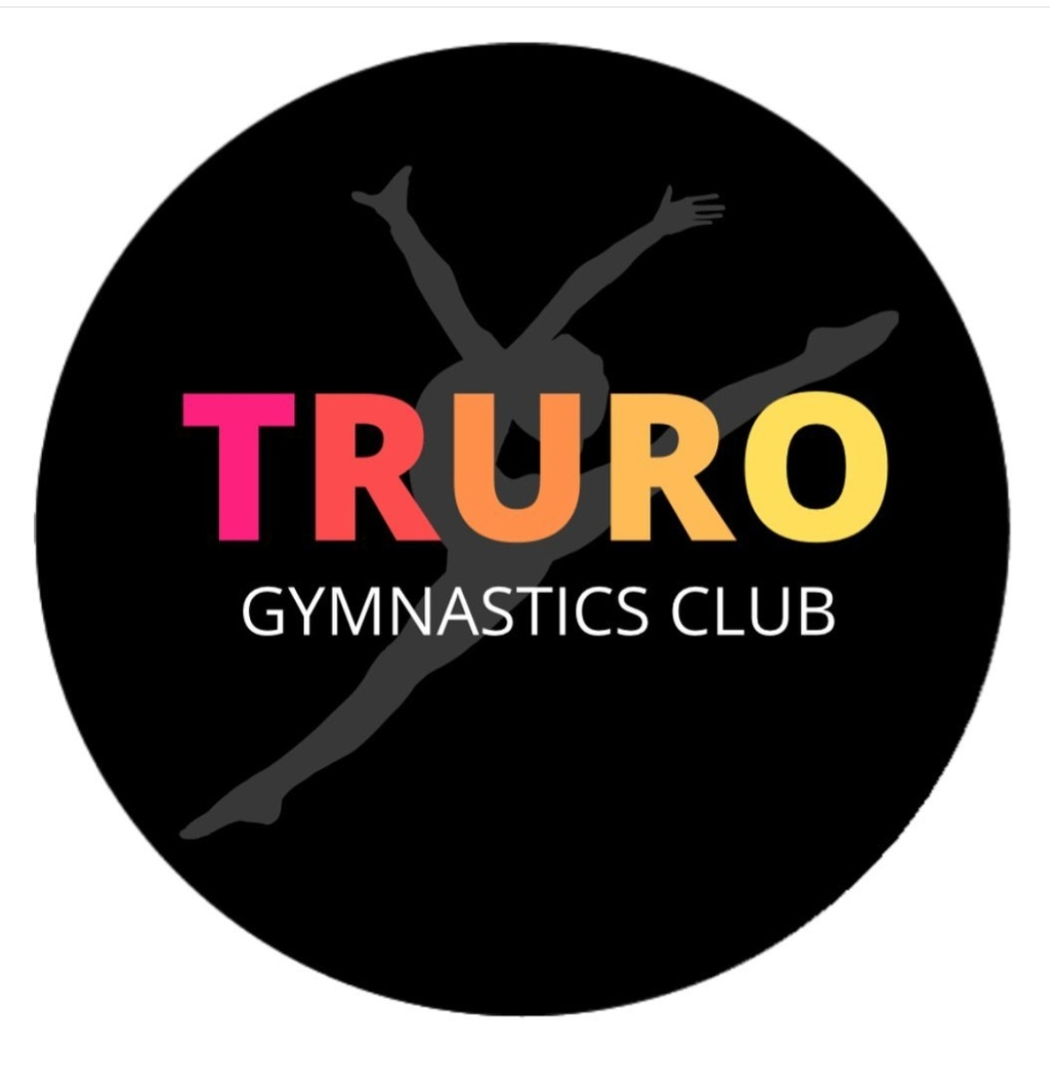

Truro Gymnastics Club Standards of Conduct for Parents and Guardians

The essence of good ethical conduct and practice is summarised below

Please read through the following parental obligations and expectations:

- Encourage your child to learn the rules and participate within them
- Take an active interest in your child’s participation and progress.
- You will not disrespect any team member, coach, parent or official or any other gym for any reason. This includes face-to-face, telephone, text, email and social networking sites.
- Help your child to recognise good performance, not just results
- Set a good example by recognising good sportsmanship and applauding the good performances of all
- Never force your child to take part in sport or place undue pressure on your child or other athletes to perform, participate or compete.
- Always ensure your child is dressed appropriately for the activity and has plenty to drink
- Keep the club informed if your child is ill or unable to attend sessions
- Endeavour to establish good communications with the club, coaches and officials for the benefit of all
- Share any concerns or complaints about any aspect of the club through the approved channels
- Use correct and proper language at all times
- Never punish or belittle a child for poor performance or making mistakes
- Always assume responsibility for safe transportation and attendance to and from training, performances and competitions.
- Keep emergency contact details and any medical changes up to date with the club and assume responsibility if I fail to do so.
- Ensure your child’s fees, including competition fees are paid in full and accept that is this is not adhered to that my child may not be able to participate in the session or competition.

